2D Animation & 3D Modelling 35s
Teacher: Ms. B. Hammond
Contact Information: bhammond@bpsd.mb.ca
Class Website: www.mshammondsclass.weebly.com
Remind101 Info: Phone Number: 204 800 4184 & Code: @2danima

Periods 3-4 Semester One Room 206

Course Overview:
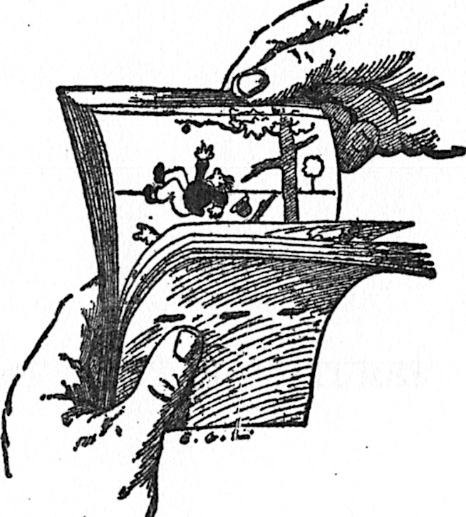
Welcome to 2D Animation and 3D Modelling 35S! The purpose of this course is to provide you with the skills and knowledge necessary to create two-dimensional animations and 3-Dimensional models. In addition to the specific skills of animation and modelling, an emphasis will also be placed on more general ICT skills, including inquiry, communication, digital citizenship, evaluation, problem-solving, and teamwork.
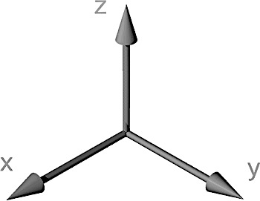

Supply List Program List
8GB Flashdrive/USB Stick Adobe Flash
Earphones/Earbuds Google Blogger
Writing Utensil & Notebook Google SketchUp
Blender

Classroom Tools & Procedures
It is my goal to run an almost entirely paper-free course. This means two things: 1) You will not need a binder for this course (everything you create will be stored on your website), and 2) There are some important tools and procedures:
- The S Drive: You will hand most of your assignments in to the “Hammond” “Hand in” folder located in this drive
- Ms. Hammond’s Website: You will retrieve most of your assignments and instructions here
- Remind101: I will send out homework reminders to your cell phone or email using this app (which we will set up together). This is a way communicate outside the classroom without getting personal phone numbers involved.
Classroom Rules & Expectations
All members of the classroom will…
- Commit to making the classroom a safe space. Therefore:
  - All members of the classroom will be respectful of the opinions, ideas, culture, and overall person of other members of the classroom, whether they agree with them or not.
- Respect their classmates’ right to learn & work within a school environment. Therefore:
  - There will be no talking during instruction, and no distracting behaviour during work time.
- Use technology in a relevant and respectful manner.
  - The use of electronic devices is essential to this course. However, access to them is a privilege and not a right. Therefore, these devices (desktops, cameras, cell phones, etc.) must be used only for academic purposes during class time (and not at all during instruction), or this privilege will be taken away.
  - MUSIC – Independent work = 1 earbud in, 1 earbud out, Instruction = 0 earbuds in, 2 earbuds out
- Come prepared for class by bringing any tools and materials necessary for class, and saving your work.
  - Students must bring their flashdrives/USB sticks to class every day.
  - Students are also responsible for saving their work frequently, and in multiple places. If any work is lost or is not saved, it is the student’s responsibility to redo this work outside of class time.

Assessment Guidelines
- Assignments are due at the beginning of class on the predetermined due date.
  - If this is a problem, you are expected to discuss this with me ahead of time.
- Late assignments will receive a zero until the assignment is handed in.
  - If assignments are continually handed in late, a parent-teacher-student conference will occur.
  - Once a unit of study has been completed, you may no longer hand in assignments for that unit.
- Plagiarized assignments will receive a zero until the assignment is redone and resubmitted, and will warrant a serious discussion with Ms. Hammond, your parents, and possibly administration.
- Bombed assignments may be redone and resubmitted…as long as the original copy was submitted on the original due date. If you are willing to put in the effort, I am willing to help you succeed.
- If you miss a class or come in late, it is your responsibility to find out what you missed and access the materials. I will keep them archived on the class website.
2D Animation
Course Learning Outcomes
- Define the purpose and audience for an animation
- Develop a plan for animation by creating storyboards, timelines, and to-do lists
- Use animation software to create, morph, and animate visual and sound objects
- Choose frame rate, screen size, and file size based on use of animation
- Incorporate interactive features to control animation (eg. buttons, counters, etc.)
- Critique and accept critique on animations given specific criteria
*For more information visit: http://www.edu.gov.mb.ca/k12/cur/ict/framework.pd

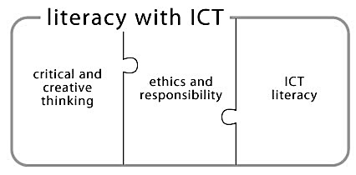

Course Overview
Introduction to Blogging (0.5 weeks, ongoing) 10% of Course Grade
Throughout the entirety of this course, students will maintain their very own Blogger blog website. Their blogs act as a portfolio to record their learning on the various topics studied in class. The process of creating and maintaining a blog, students will learn about protecting their privacy, how to be an upstanding digital citizen, how to reflect on and organize their learning, and how to develop a sense of online community. Assignments may include:
- 2D Animation Blog – Reflections on Learning 10%
Assessed for continuity, relevance, quality, and digital citizenship

A History of Animation (1 week) 15% of Course Grade
This unit will serve as an introduction to animation, wherein students will learn about the evolution of animation, the important terminology and procedures involved in animation, and the career opportunities available to them in this field. In order to fully appreciate the progress animation has made over the years, students will study its various stages in-depth and even get a chance to experiment with some of the more primitive forms! Assignments may include:
- “Introduction to 2D” Scavenger Hunt 20%
- Study & Creation of Animation Artifacts 05%
- Kineograph (Analogue Flipbook) 75%

Stop Motion & Storyboarding (2.5 weeks) 25% of Course Grade
A well-defined plan equals a well-received product. Because of this, students will spend the first part of this unit brushing up on their planning and organizational skills, as they generate an idea for a 15-second stop motion animation, script and storyboard their idea, then pitch it to their classmates. During the second part of this unit, students will work in partners to photograph their props/characters, record their audio, and edit their stop-motion animations using Premiere Pro Elements. Assignments may include:
- The Planning Process: Storyboard & Script 20%
- The Peer Critique: Self & Peer Feedback and Assessment 10%
- 15-Second Stop Motion Animation 70%

Computer-Generated Images in A. Flash (6 weeks) 50% of Course Grade
The third, and final, unit of study brings us to modern times in our study of 2D animation: Digital Animation using CGI, or computer-generated images. For the majority of this unit, students will be using Adobe Flash, an industry-standard 2D-animation software, to generate animations of varying difficulty. After learning the basics of animating movement using the Pivot Stickman program, students will learn the ins and outs of Adobe Flash by digitally animating their flipbook from Unit 1. Once they’ve grasped the basics, they will move on to some more advanced procedures, including morphing, tweening, and installing interactive elements within their animations. For unit’s final project, students will apply their digital animation skills by creating an independent animation project of their choice (the details of which will be discussed with me before proceeding). Assignments may include:
- Pivot Stickman Cartoon: The Basics of Movement in Animation TBA
- Flash Introductory Exercises 10%
- Digital Flipbook: A Journey from Analog to Digital 50%
- Flash Advanced Exercise: La Pelota 10%
- The Mini-Lesson Movie: Interactive Animation (using ActionScript) 30%

3D Modelling
Course Learning Outcomes
- Describe the uses of 3D Modelling
- Describe the basic principles of 3-D Modelling (3D space, coordinates, axes, perspectives, lighting, rendering)
- Define the audience and purpose for a 3D model
- Build and enhance the presentation of 3D objects using various 3D tools and properties
- Light an object to create shadows, shading, reflection, and ray tracing that looks realistic upon rendering
- Critique and accept critique on 3D models given specific criteria
*For more information visit: http://www.edu.gov.mb.ca/k12/cur/ict/framework.pd

Course Overview
Blogger Blog (0.5 weeks, ongoing) 10% of Course Grade
Throughout the entirety of this course, students will maintain their very own Blogger blog website. Their blogs will serve two purposes: 1) a sort of portfolio to record students’ learning on the various topics studied in class, and 2) a logbook to track their progress as they complete their final project. Through the process of creating and maintaining a blog, students will learn about protecting their privacy, how to be an upstanding digital citizen, how to reflect on and organize their learning, and how to develop a sense of online community. Assignments may include:
- 3D Modelling Blog – Reflections on Learning 10%
Assessed for continuity, relevance, quality, and digital citizenship

Introduction to 3D Modelling: Google Sketchup (~2 weeks) 20% of Course Grade
This unit will serve as an introduction to 3D modelling. In this unit, students will be introduced to the 3D workspace, navigation controls, and basic tools used in the 3D modelling process through their use of Google Sketchup software. Students will apply the skills they learn to a project that requires them to research, design, and model their dream house. Assignments may include:
- “Introduction to 3D” Scavenger Hunt 20%
- Mini-Tutorials: Learning the basics of Sketchup & 3D Modelling 05%
- Modelling Assignment: “Tiny Dream Home” floorplan and 3D model 75%

Basics of 3D Modelling: Blender (~6 weeks) 60% of Course Grade
By now, students should have mastered the basic principles of 3D modelling and will be ready to move on to a more complex modelling program, like Blender. In this unit, students will work towards developing an understanding of a variety of tools (such as bridging, merging, sculpting, modifying, morphing, and extruding) that can be used to make their models more life-like. They will study 4 basic components of mesh modeling: object quality, tool usage, material application, and rendering. Students may also take a look at animating in 3D, although this is dependent on the amount of time it takes for students to complete their 3D models. Assignments may include:
- Modelling Tutorials – Robot, Coffee Cup, Alarm Clock, UV Cube 20%
- Modelling Assignment – Basic Shapes: The Primitive Mesh Object 20%
- Modelling Assignment – Basic Concepts: The Household Object 30%
- Modelling Assignment – Character Creation: The Household Occupant 30%

3D Printing (Ongoing) 10% of Course Grade
The final unit of study will allow students to take a closer look at 3D Printing using NACI’s very own Makerbot Replicator 3D printer. Not only will students get an opportunity to study a new technology that is taking the world by storm, but they will get to design, model, export, and print using this technology. Assignments may include:
- Inquiry Assignment – Industrial 3D Printing: A Case Study TBA
- Modelling Assignment – Printable Model TBA

Final Note for Students:
It is no secret that I am relatively new to the world of ICT, as I have been an English teacher in previous years. However, I look forward to working together as we continue to learn about 2D Animation and 3D Modelling 35S, which I know will grow to be one of my favorite subjects (and I hope yours, as well). I want you to know that, above all, I am dedicated to helping you succeed in this class, and will do my very best to make myself available during noon hours and after school, should you need any assistance outside of class. If you are a social savant, extra-curricular extraordinaire, or plain ol’ workaholic, and you don’t have time to meet, DO NOT be afraid to shoot me an email or shoot up your hand in class. Best wishes heading into 2D Animation and 3D Modelling 35S – here’s to a fantastic semester!

Final Note for Parents:
I look forward to working with your teen, and helping to explore his/her identity, goals, and creativity. Just as I welcome your son or daughter to be a part of the classroom community, I welcome you as well! I encourage you to call, email, or stop by the classroom as much as you like. If you have any questions, comments, or concerns – however large or small – please, do not hesitate to contact me. On that note, it is important for me to provide you with progress reports, and email is an easy way to do this. If possible, please provide me with your email address in the section below. If you do not have an email address, I will keep you updated via phone or standard mail.

After BOTH you AND your parents have read through this course outline:
- Throw down your signatures.
- Return your course outline.
- Hand it in to me for a chance to win a SWEET PRIZE.

I have read the 2D Animation and 3D Modelling 35S course outline and am familiar with its contents. I have reviewed the classroom rules and expectations and am prepared to participate in a positive way according to these rules and expectations. I understand that this is a classroom contract and will try my best uphold it.

Date Read: ______________________________________________________________

Student’s name: __________________________________________________________
Student’s signature: _______________________________________________________

Parent/Guardian’s name(s): ________________________________________________
Parent/Guardian’s signature(s): _____________________________________________
Parent/Guardian’s Email Address: ____________________________________________

Any initial comments or concerns: ___________________________________________________________________________________
____________________________________________________________________________________________________________________
____________________________________________________________________________________________________________________



