Alarm Clock Tutorial – Notes
Part 1: https://www.youtube.com/watch?v=Ay7fgeQC1WI
Part 2: https://www.youtube.com/watch?v=T70ia5GMmzo

Getting Started:
In your Blender folder, create a new folder called “loginname_alarmclock.” Open a new Blender document and save it within this folder as “loginname_alarmclock.” Once you’ve finished modelling your cup, you will render an image (title it whatever you want) and save it inside this folder, as well!

In this tutorial, you will learn how to:
- Work in Edit Mode (separate parts of an object = p > selection)
- Add (but NOT apply) solidify and subdivision surface modifiers
- Apply Bitmap Images as Materials
- Use the UV Editor Window

Supplementary Notes:
These notes are meant to provide 1) a sort of table of contents, 2) information that will help you understand what you are doing in each step of the tutorial, 3) sidebars that will help you follow along with the tutorial, 4) shortcut keys and additional information. Notes are placed in chronological order, and are organized by the time at which they occur in the video.

Tips & Tools:
02:26 – Return 3D Cursor back to center Shift + C
02:49 – Add an object to the scene Shift + A
05:08 – Toggle between Deselecting and Selecting all objects A
05:42 – Select vertices by drawing a Box around them B
06:00 – Duplicate selection Shift + D
06:15 – Separate selected part of an object P > Selection
20:15 – Render your model F12
20:15 – Exit back to 3D View ESC
20:15 – Toggle between 3D View and Image Editor F11

PART 1

00:00-00:58 – NOTE: You can skip this part of the video (you already know how to navigate in Blender)

06:35 – NOTE: Make sure that the “Num Lock” feature on your keyboard’s number pad is enabled

07:10 – Apply a smooth effect by going to the Tools Tab > Shading > Smooth
07:16 – Apply thickness to an object by adding a Solidify Modifier
07:40 – Add detail to an object by adding a Subdivision Surface Modifier

08:20 – NOTE: If no option to select “Use Nodes” appears, it means that it is already selected.

10:30 – NOTE: The bitmap you will be applying to your clock face is in the Shared > Hammond > Hand Out > 3D Modelling folder. It is called “clock_face”

10:45 – To apply a bitmap (jpeg, png) file to an object, you will need to add it as a new material. The workflow for this task is listed below:
- Materials Tab > New > Color (click the tiny circle button on the right) > Image Texture > Open > Image Name (note: you may have to do some navigating, depending on where the image is located within your files)

11:15 – To position the bitmap to where you want it, you must Unwrap the bitmap via UV Mapping. To do this, you will need to (temporarily) change your screen layout to include the UV Mapping workspace . The workflow for this task is listed below:
- Choose Screen Layout button (at top of screen) > UV Editing (this will split your screen in two)
- To go back to your previous workspace go to the Choose Screen Layout button > Default

11:40 – NOTE: If, when you switch to Edit Mode, your clock face image does not show up in the UV Editor window, in the UV Editor window, click on the “Browse Image to be Linked” button, then on “clock_face.png” (see image below):

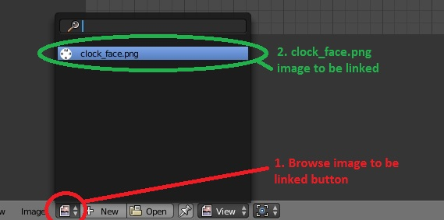

11:40 – NOTE: If, when you switch to Edit Mode, your entire clockface object is not selected (this means that the lines inside of it are black, and not orange like they’re supposed to be), click the A key to “select all.” Now, your clockface object should be completely highlighted in orange, and you can move on to the next step (unwrapping your image).
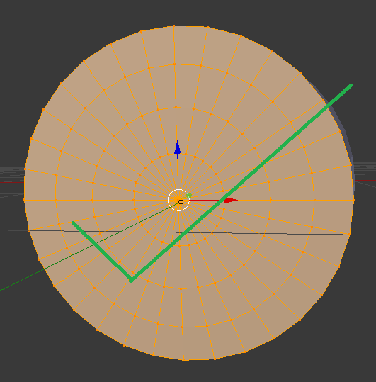
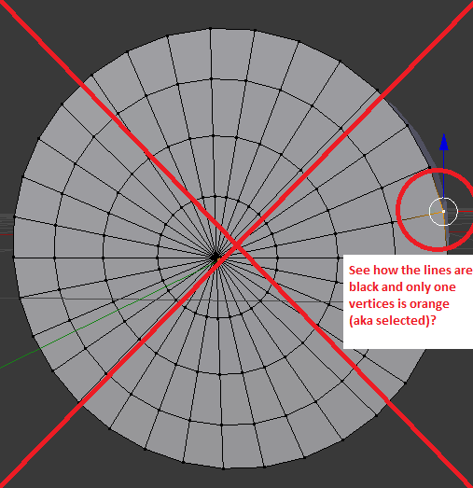

11:42 – To unwrap a bitmap image for UV Editing, follow the workflow below:
In the 3D View: Mesh (at the bottom of the screen) > UV Unwrap… > Unwrap

15:35 – Even if you don’t use the same colour as the tutorial, make sure to use the same colour for both shaders. This can be done by selecting the Eye Dropper tool from the Color Popup, and using it to click on the colour you set for the first shader.

16:09 – When you use a Mix Shader, the Fac (aka Factor) option works as a slider between your first shader (at the top of the panel) and your second shader (at the bottom of the panel), where a value of 0 means that only the first shader is showing, and a value of 1 means that only the second shader is showing. Any numbers in between represent a combination of the two.

NOTE – Save your project as “AlarmClock” inside “loginname_AlarmClock” folder that you created before beginning this tutorial.

PART 2
01:25 – To turn off visibility of select objects: Properties Panel > Scene Menu > Eye Icons

08:25 – NOTE: Make sure to press Shift + C to center your 3D Cursor

16:00 – NOTE: Make sure that you are consistently viewing your model from all angles, to ensure that all the different objects that make up the model are all properly aligned with one another

20:00 – NOTE: It is a good idea to save your project before rendering, in case something goes wrong during the rendering process. Rendering takes a lot of CPU (processing power) from your computer, which could cause it to freeze.

21:10 – NOTE: For the love of all that is good, DO NOT render at 1000 samples. You will be here all day. Render using approx. 500 samples, depending on how much class time you have left. You can check how quickly your render is progressing by looking at the top of the screen where it says “Render,” then shows a progress bar below.

NOTE: Save your rendered image as “AlarmClock_YourName” inside the “3D_AlarmClock_YourName” folder that you created before beginning this tutorial. Hand the entire folder in to Ms. Hammond.

While you are waiting for your image to render, respond to the questions below:

QUESTIONS

- What is the function of the 3D View? The Image Editor? The UV Editor?

- How can you change back and forth between different Views/Windows in Blender?

- What are some ways in which you are able to preview the colours and textures you apply to your object?

- What does a “solidify” modifier do? A “subdivision surface” modifier?

- Why might you want to add a subdivision surface modifier? Why might you not want to actually apply it to your model?

- Notice how, while adding smoothing effects and subdivision surface modifiers can help, you are still not able to see exactly how your finished product will look. How can you check to see if your object is turning out the way you want it to?

- Is it necessary to have a surface for your model to sit on? Why/why not?

- Is it necessary to have at least 1 light source in your model? Why/why not?

- What are 2 different methods of adding light to your models that you’ve learned about so far?

- How can you determine where to place your light(s)? Where are some common places?

