Lesson 3: Structure & Comment Tags

The Learning:
Organizing your Content using Structural Tags
*READ the following information about structural tags, then use it to help you complete “The Doing” section below.

Question: Why is it important to properly structure content?
Answer: It is important to structure content properly so that a document outline can be created. This is important for people using assistive technology (read-aloud software, for example) and for machines, such as search engines.

HTML 4 (the old version of HTML) vs. HTML 5 (the new version of HTML)
The tags used for organizing and structuring content are different when it comes to different versions of HTML code. HTML 5 (the newest version) offers several new codes to help you organize the information on your page into meaningful sections that help search engines like Google find and display the content on your site, and help viewers find information quickly.
- In HTML 4… only the 6 heading tags (<h1>…<h6>) were used, since they were the only structural tags invented at the time – each header being used to organize content from the most important (<h1>) to the least important (<h6>).
- In HTML 5… a new document outlining structure has been created. This structure combines heading tags with other SECTIONING and SEMANTIC ELEMENTS – therefore you must use both when structuring your page. These will become even more important when we move onto CSS (cascading style sheets).
  - NOTE: As of right now, HTML 5 structural elements are not universally accepted by web browsers so, just to be on the safe side, it is very important to continue using Headings at this time.

The Sectioning Elements (all CONTAINER tags = open & close tag):
- <h1>…<h6> - heading tags
- <section> - represents a thematic grouping of content; the theme of each section should be identified by including a heading as a child of the section element
- <article> - very similar to the section element (*use <section> instead)
- <aside> - represents a section of a page that consists of content that is tangentially related to the content surrounding the aside element, but which could be separate from this content; this element is akin to a “sidebar” in print communication; this is typically secondary content/information
- <nav> - represents a section of a page that links to other pages or parts within the page; a section with navigation links
- <div> - represents a group of content, but has no specific meaning (unlike the section, nav, aside elements); to be used when no other structural element is suitable; can be used for grouping in cases of stylistic elements

The Semantic Elements (all CONTAINER tags = open & close tag):
- <header> - represents introductory content for its nearest parenting content; typically contains a group of introductory or navigational aids; typically contains the section’s heading, but this is not required
- <main> - represents the main content of the body of a webpage; includes content that is unique to that document and truly identifies the main idea of the page; it may only be used ONCE on a page; can be as long or short as needed; this is really helpful for search engines when indexing your site
- <footer> - represents a footer for its nearest parenting content; typically states information about the page (such as who wrote it, copyright information, contact information, publication information, additional notes about the website, etc.)

Document Outlines
Using these tags will produce a “Document Outline” that will help viewers and search engines organize and understand your website’s content. To see how organized your site’s document outline looks, you can copy and paste our code into the HTML 5 Outliner engine:
- https://gsnedders.html5.org/outliner/

The Doing:
Activity (8):
Open the html code document titled “outline_practise” and edit this code, adding in BOTH the sectioning (/5) and semantic (/3) HTML 5 structural elements listed above (note: use each at least once). Check your document outline using the HTML 5 Outliner Engine. (copy and paste all of the html code from the “outline_practise” document inside the HTML section of this site and click the “Outline” button). If you’ve formatted your page correctly, it will generate a document outline that looks like this:

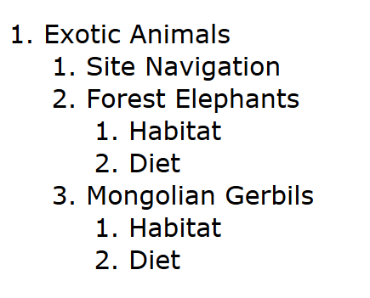
Challenge:
Inside your “notepad” folder, open up “basicorganization.html” Use the structural elements we learned in today’s lesson to properly organize your page structure, thereby creating a document outline. Check your document outline using the HTML 5 Outliner Engine.

Comprehension Questions (/2):
- (/1) What is a document outliner?
- (/1) Why is it important to properly structure content so that a clear document outliner is created?

The Learning:
Comment Tags
Comment tags are used to “mark up” or make notes within your html code that don’t affect your website’s display. This is handy when it comes to temporarily removing parts of your code, adding reminders for yourself about changes/additions that need to be made, or adding instructions for others who may be working on your code.
- Click the link below, then read through the “list” section in the Chapter 10 page only:
  - http://www.goodellgroup.com/tutorial/chapter10.html

The Doing:
Activity (/3):
Continue this activity using your “basicorganization.html” document. In your document, use your knowledge of the comment tag you’ve just learned to add 3 comments: 1 that explains why you’ve included a piece of content/code, 1 that offers a suggestion for future editing, and 1 that acts as a reminder of future content you wish to add.

Comprehension Questions (/4):
- (/1) What is the comment tag used for?
- (/2) What is different about the content tag, compared with the other tags we’ve learned so far?
- (/1) Is the comment tag container or empty?

The Handing In:
Hand your “basicorganization.html” document, “outine_practise” document, as well as this lesson3 document (with your responses to the comprehension questions included) into the Shared > Hammond > Hand-In folder.

