Magazine Cover Assignment
For this assignment, you will be creating a magazine cover for a magazine of your choosing. It may be based upon a popular magazine, or may be completely fictional! It may be completely serious or completely silly! It may be a matter of simple compositing, or you may choose to go nuts and learn something new!
Part 2: The Doing
Create Your Photoshop Document

Make the Magazine Look like a Magazine
- Make sure that your magazine includes the “What Makes a Magazine a Magazine” criteria we decided upon as a class. Type these criteria in the space below:
- Title (needs to be large and stand out, located at the top of the page, title relevant to theme)
- Cover photo (of the subject the feature article is written about)
- Consistent Theme (all articles, title, images must work together to create a clear theme)
- Headlines (article titles, usually different fonts/sizes/colours)
- Multiple Colours (that work together to look NICE)
- Barcode (usually in the bottom left/right corner)
- Date/Issue Number/Price ($3.99 May 2010 Issue #268)
- Left & Right Alignment (of headlines/articles)
- BRIEF description of magazine type/website (usually very small, at top or bottom)
- Shapes (circles, squares, rectangles used to contain text)
Need 8/10 criteria

*Tip: Use shapes in Photoshop to create headers, text boxes, and icons to incorporate with text.

- Open Photoshop, and create a New Document.
  - Change the Preset to “U.S. Paper” (or 8.5-inch width x 11-inch height)
  - Change your Resolution to 300 ppi (pixels per inch)
  - Leave the rest of the settings as their Defaults
  - Save this document inside your “DP_MagazineCover_YourName” folder (the one you will eventually hand in).

Accept a Photoshop Challenge
- Get creative with your magazine cover and build up your Photoshop skills by applying one of the following techniques to your cover image. How you go about doing this depends on which Challenge you choose to complete! Once you have selected your challenge, visit the class website to download a tutorial or two that will help you complete the challenge.
- The Merger - Merge Multiple Subjects Together (combine separate body or landscape parts)
- The Time Traveler - Age or Anti-Age Your Subject (make your subject older or younger)
- The Makeover – Makeover Your Subject (change expression, add makeup or adjust figure)

Find your Photos
- You must use copyright-free images within your Magazine Cover. Save all images you may use for your magazine cover in the “Images” folder inside your “MagazineCover” folder. Copyright-free images are also known as “open source media.” The best way to ensure that your photos do not infringe on copyright laws are to take the images yourself! I encourage you to do this for your magazine cover, but I won’t force you to. If you do choose to look to the internet for your photos, you MUST use copyright-free images. Here are some great resources:
  - Creative Commons (search Flickr, Google Images, Pixabay and Open Clipart)
  - Morgue File (use the free search option)
  - Pexels (high-quality stock images)
  - Albumarium (high-quality stock images)
  - Free Pik (vector images, photographs, PSD files, and more)
  - The Noun Project (icons for just about anything)

*Note: you must credit the image’s source by copying and pasting the URL you retrieved the image from, as well as the author’s name in the table below. Make sure that you also include a name that represents your image. Example:

Image | Author | URL
Bear | Freepik | https://www.vectoropenstock.com/vectors/preview/70690/bear-vector

Download a Font
- Create a new folder inside your Desktop Publishing folder. Name it “Fonts.” This is where you will save any and all fonts you use in your assignments this semester.
  - Visit one of the following sites (or any other font site you know of), then scroll through the different font examples until you find one you like.
    - http://www.1001freefonts.com/
    - http://www.dafont.com/
    - http://www.urbanfonts.com/free-fonts.htm
  - To download the font to your computer, click the “Download” button. In the dialog box that pops up, click “Save File.” This will download a “zipped” folder containing the font information.
  - Follow the same steps as when you download something off the class website to cut the file from your Downloads folder and paste it into the Fonts folder you created.
  - Double-click on the Zipped file to unzip and open it.
  - Double-click on the Font file (tiny document icon with an ‘A’ in the corner). A preview of the font in various sizes will pop up.
  - Finally, to install the font, click the “Install” button at the top of the window.

*Note: You may have to re-install the font each time you log in to your computer.

Follow the 4 Elements of Good Design
- Follow these Elements of Design to help make your piece easier on the eyes, and easier to read. They will help your reader focus on what is most important, carve out a path for the eye to follow when reading and, most importantly, they will tie all the separate elements in your cover together to create a clear message or theme.
  - Proximity – grouping related items together. This creates structure and organization!
  - Alignment – arranging your content into lines or, symmetry, that balances each other out. This helps to create structure and organization!
  - Repetition – finding an element (ex. font, colour, graphic, shape, line) in your design and repeating it throughout your piece. This adds unity, or, cohesion!
  - Contrast – making elements on the page very different. Making them the same can result in cohesion, but making them similar can result in a very bland piece that is difficult to read and navigate.

*TIP: Use guides to help you arrange your content according to the Elements listed above
*NOTE: For examples of each element, see the bottom of this document.

Check it Over
- Make sure that you have taken all the basic steps to make your .PSD file organized, and your .JPEG file look polished and professional. This means:
  - Your layers that are named, properly stacked, and organized into folders
  - You’ve applied adjustment layers, blending modes, layer affects, and opacity changes
  - You’ve used and applied layer masks and selection tools to make neat, sharp selections
  - A variety of brush types, feathering/hardnesses, and sizes have been used appropriately

Hand it in
- Hand in your DP_MagazineCover_YourName folder into Ms. Hammond’s “Hand-In” folder. Your folder should contain the following:
  - Planning Document
  - .PSD document
  - .JPEG document

--------------------------------------------------------------------------------------------------------------------------------
EXAMPLES: 4 Elements of Good Design
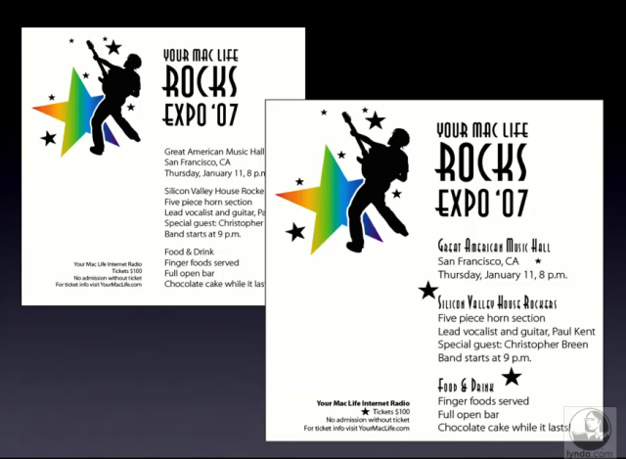
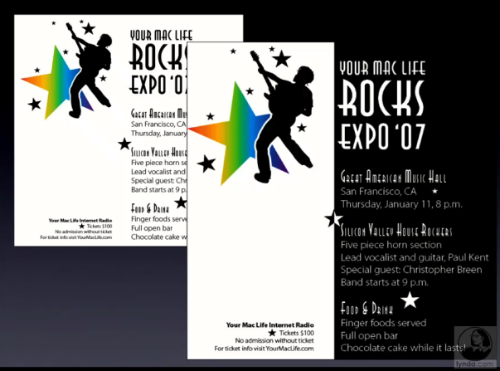
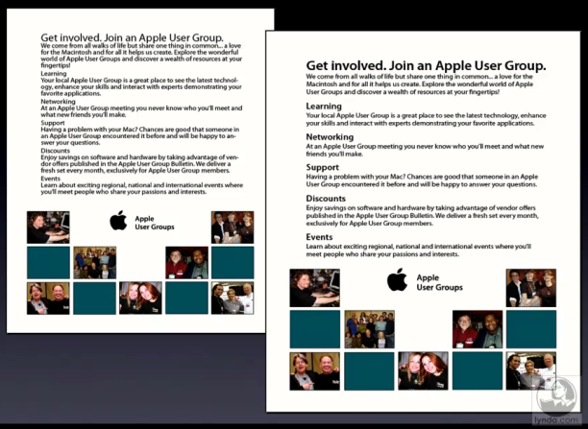
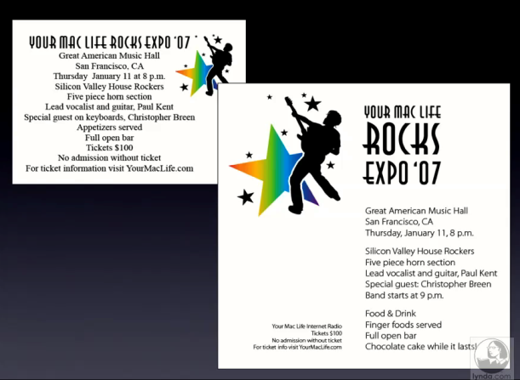
Contrast
Repetition
Alignment
Proximity

