Assignment: NACI Logo

Overview:
Use the skills you’ve learned by completing the Personal Crest tutorial, and Skills Scavenger Hunt to create a new version of the NACI Tigers logo! Use some of the existing school logos as a starting point for your design – heck, even feel free to trace some pieces of them and add on.

Reminder: Some Key Skills to Use:
- The Pathfinder tool (used to merge/unite/subtract shape paths)
- The Path > Join function (used to join two anchor points to form a single path)
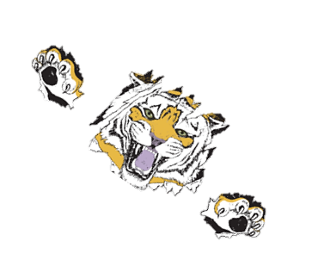
- The Object > Group/Ungroup function (used to group separate paths together to make them easier to move around and work with as a group or to break groups apart into individual objects)
- Custom Drawing and Tracing (using the Pen, Pencil, Brush, or Line tools)
- Using the “Hidden” Pen Tools (to add/remove/convert anchor points along a path)
- Using and Creating Custom Scatter and Art Brushes (and turning existing paths into brush strokes)
- Tracing Bitmap Images (make sure to edit these paths in some way, or to use only copyright-free photos and graphics so as to avoid plagiarism)
- Converting Text to Outlines (so that you can edit each individual character’s path)
- Envelope Distort > Warp Text (so that you can adjust the shape of an entire piece of type)
- Type on a Path (allows you to create an illustration/shape/path, then align text to it)
- Pattern Fills (allows you to use Illustrator’s patterns or create your own to fill your text/shapes)
- Clipping Masks (allow you to fill text/shapes with a background image/shape/etc.)

Your Logo Must Include |  | You Must Use 3 Skills from Above |  | You Must Hand In
A vector graphic |  | Skill 1: |  | .AI file (working file)
Some sort of type |  | Skill 2: |  | .PNG (of logo placed on template)*
Stroke and Fill colour |  | Skill 3: |  | .PNG (of logo realistically sized)*
 |  |  |  | .doc (planning document)*

*.PNG Logo: Placed on template
- Copy and paste a copy of the “LogoTemplate” bitmap that applies to your logo (you may choose from sweatpants, a t-shirt, a hat, or a gym bag) from the Shared drive. Place it into your Illustrator file on a separate layer called “template.” Resize and place your logo so that it aligns properly with your template to give your audience a good idea of what the final piece of clothing will look like once the logo is applied.

*.PNG Logo: Realistically sized
- Export a .PNG of your logo by itself, so that it is sized the way it would need to be to fit your chosen item of clothing, so that it has a transparent background, and so that the resolution is high enough to produce a quality print. To do this, you will need to think about how large, on average, the piece of clothing you wish to apply it to is, then measure it out and resize it using your document rulers.

*.doc: Planning Document
- Prior to beginning your logo in Illustrator, you must plan out your design using the “LogoPlanning” document, which you can download off the class website, then get it approved by Ms. Hammond.
