CHECK MAGAZINE TUTORIAL: PART 1
Set Up Your Site & Project Files

In Part 1, you will learn…
This tutorial introduces you to the concept of an Adobe Dreamweaver CS6 site and shows you how to set up the project files for the Check Magazine sample website. In Dreamweaver, a site generally consists of two parts: a collection of files on a local computer (the local site) and a location on a remote web server to which you upload files when you're ready to make them publicly available (the remote site). You use the Dreamweaver Files panel to manage the files for your site.

The most common approach to creating a website with Dreamweaver is to create and edit pages on your local drive, and then upload copies of those pages to a remote web server for viewing on the web. In this tutorial, you'll learn how to set up only the local site so you can begin building web pages right away. Later, after you've completed the website, you'll learn how to create a remote site so that you can upload your files to a web server.
In this first part of the series, after a brief introduction to Dreamweaver sites you will complete the following tasks:
- Set up your project files
- Define a local folder

Note: The screen shots for this tutorial series are from the Dreamweaver Creative Cloud 12.1 update. However, the instructions apply equally to the original version of Dreamweaver CS6. You should also be able to follow the instructions on Dreamweaver CS5 or CS5.5

---------------------------------------------------------------------------------------------------------------------

Understanding Dreamweaver sites
In Dreamweaver, a site organizes on your local computer all the documents associated with your website and lets you track and maintain links, manage files, share files, and transfer your site files to a web server. Think of your Dreamweaver site as the "bucket" that contains all of the files and assets for your website.

A typical Dreamweaver site has at least two parts:
- Local Folder: This is your working directory. Dreamweaver refers to this folder as your local site. The local folder is usually a folder on your hard drive.
- Remote Folder: This is where you store your files on the computer that is running your web server. The computer running the web server is often (but not always) the computer that makes your site publicly available on the web.

In some circumstances, you might have more than one remote folder. For example, if you work in a team environment, all members of the team might upload their files to a common testing server before they are deployed on the live website.
To get started you simply need to give your site a name, and tell Dreamweaver where you want to store the files on your local computer. Dreamweaver CS6 automatically prompts you for further information about the site setup only when it’s needed.

---------------------------------------------------------------------------------------------------------------------

Set up your project files
When you create a local site, you can place any existing assets (images or other pieces of content) in the local site's root folder (the main folder for the site). That way when you add content to your pages, the assets are there and ready for you to use.
The sample files for this article contain assets for the sample website you'll build in this tutorial series. The first step is to copy these assets to an appropriate folder on your hard drive:
- Decide where you want to store your website files on your hard drive. The folder can be anywhere on your computer, but the more organized it is the easier it is to find later. I recommend that you set up your folders for this assignment in this way:
  - Web Design > CSS > assignments > checkmagazine_assignment
- Download the first_website_pt1 files from the Shared folder (Hammond > Hand Out > Interactive Websites > checkmagazine_tutorial > check_cs6) if you haven't done so already.
- Copy the check_cs6 folder into your checkmagazine_assignment folder.
- You will use the check_cs6 folder as the root folder (main folder) for your Dreamweaver site.

Note: The local root folder of your Dreamweaver site is normally the main or top-level folder for your website. It usually corresponds to a folder named public_html, www, or wwwroot on your remote server. For example, if you have a website at www.example.com, and have a file named news.html in the root folder, its URL is http://www.example.com/news.html. The normal practice is to give your local root folder the same name as the website without the top-level domain (such as .com or .org). For example, one could store the files for his/her website at http://foundationphp.com in a folder named foundationphp on his/her local hard drive.

----------------------------------------------------------------------------------------------------------------------------

Define the local site folder for the Check Magazine site
You must define a Dreamweaver local site folder for each new website you create. Dreamweaver needs to know where your site files are to create all the internal links correctly, and to update them when you move files to a different location within your site.
Next, set up the site for this tutorial series, and define the check_cs6 folder you copied into your checkmagazine_assignment folder as your local site folder:
- Start Dreamweaver and choose Site > New Site. The Site Setup dialog box appears.
- For the Site Name, type Check Magazine as the name of the site. The name is used internally by Dreamweaver to identify the site. It doesn’t matter if it contains spaces.
- Click the folder icon next to Local Site Folder to browse to and select the check_cs6 folder (see Figure 1).
- Click Save. That's it!
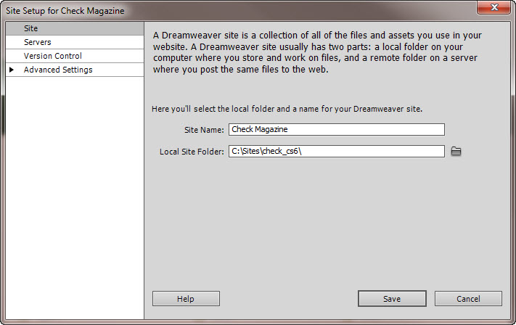
Figure 1. Defining the local site folder for the Check Magazine site.

Note: The file paths will differ, since you have stored your check_cs6 files in a different folder on your hard drive.

The Files panel in Dreamweaver now shows the new local root folder for your current site (see Figure 2). The file list in the Files panel acts as a file manager, enabling you to copy, paste, delete, move, and open files just as you would on a desktop (in Windows Explorer).

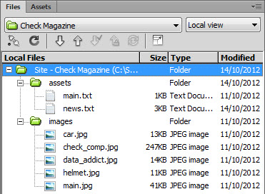
Figure 2. List of files in the Files panel

----------------------------------------------------------------------------------------------------------------------------

Best practices for naming files and folders in a website
A typical website contains a large number of files and folders. For ease of maintenance, it’s important to organize them logically. Create separate, appropriately named folders for images, videos, style sheets, and external JavaScript files (which we will explore later). Also keep these points in mind:
- File and folder names in websites should never contain spaces or any of the following characters: /\?%*:|”<>.
- Although other special characters are permitted, it’s generally a good idea to use only alphanumeric characters, hyphens, and underscores.
- Most file and folder names end up as part of a web page’s URL, so keep them short, but meaningful. Long URLs are difficult for users to remember and type into browsers on a mobile device.

The vast majority of websites are hosted on Linux servers, which are case-sensitive. Using all lowercase letters for file and folder names avoids problems with files not being found.

----------------------------------------------------------------------------------------------------------------------------

Review Questions:
- What is the difference between a local and a remote folder?
- How does Dreamweaver help keep the files and folders within your website organized?
- What are some important practices to keep in mind when naming the files and folders within your website?
- Why is it important to name your files and folders logically and intuitively?

----------------------------------------------------------------------------------------------------------------------------

Where to go from here
Now that you have finished defining your site, you can begin building your web pages by following the steps in the next tutorial in this series, Part 2: Creating the page structure.

