Pivot Stick Figure Animator
Activity #3: Your Choice

Your Task: Create an animation of a stickman performing an athletic activity of your choice. You get bonus points for having more than one figure (another stickman, ball, creature, etc.) on your stage.
- The tough part of this assignment is visualizing your activity so that you can make the movement as accurate and realistic as possible. To help you with this:
  - Look up your desired movement on Google or YouTube
  - Partner up and model what it looks like to perform this activity for one another
  - Slow down, or speed up your animation so that it looks natural

Settings: Change your screen size so that is set to 800x600 (widthxheight) pixels.
- You can do this by clicking the “options” tab at the top of the window.

Background: Load one of the other background files from Ms. Hammond’s “Hand Out” folder. These are all set to be 800x600 to match your stage. If you don’t like any of these backgrounds, you may choose your own – but make sure it is as close to 800x600 as possible (anything less than 600x400 is too small, anything more than 1000x800 is too large). Make sure your background makes sense for your animation.
- How to load background in Pivot Stick Figure: File Load Background
  - Make sure that the “files of type” is set to “jpeg,” not “btmp”
- Location of “Hand Out”: Shared Drive Hammond Hand out 2D Animation

Length Requirement: 5 seconds

Saving: Create a folder within your Animation Folder called “loginname_PivotStickFigure.” Save your pivot as both a working file (.piv) and a GIF (.gif) file inside this “loginname_PivotStickFigure” folder. Once you have completed all 3 Pivot Stick Figure activities, you will hand a copy of this folder in to Ms. Hammond’s Hand In folder.

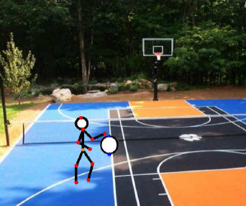

Checklist for Success:
- (1 mark) Choice background picture has been added
- (1 mark) Choice background makes sense for animation
- (1 mark) More than 1 figure is animated on the stage
- (3 marks) Idea is challenging and creative
- (3 marks) Animation is 3-5 seconds long
- (5 marks) Action cycle is smooth & believable
- (1 mark) Animation has been exported as a GIF (.gif)

/15 marks + BONUS

