Assignment: NACI Motivational Poster

*Don’t forget to press the Enter key to apply any transformations*

Overview:
By now, you should have already showcased your photography skills by capturing a variety of portrait and action shots of your nominee. Now it’s time to pair these skills with your image editing skills in Adobe Photoshop, where you will combine your favorite photos with other graphics, shapes, and text to create a motivational poster starring one of NACI’s very own students. These posters will be printed in full colour, and proudly displayed along NACI’s halls.

Step 1 – Set Up Your Document
Open a new Photoshop document. Select the following options:
- Name: loginname_nomineename-poster
- Width: 20 inches
- Height: 30 inches
- Resolution: 150 pixels per inch
- Color Mode: RGB Color 8 bits
Open each of the images you will be using in your poster and drag them into your new document. Each will automatically be separated onto its own layer.
- Color your background black (using the color picker and paintbucket tools)
- Arrange your layers so that the foreground images are at the top and the background images are at the bottom.
- Name each layer something relevant to the image that is on it.
- Duplicate any layers containing photographs of your nominee and keep them as backups in case something goes wrong (turn off these layers’ visibility).

Step 2 – Set Up Your Guides and Draw Your Borders
Since we want all the motivational posters to follow the same formatting theme, it is important that you create guides that will help you create centered and consistent borders for your images (note: borders may be adjusted to suite your needs – just ask Ms. Hammond before making any adjustments). Turn on your document’s rulers (view > rulers), temporarily set the unit to inches, then add the following guides (view > new guide…):
- Vertical – 1.75, 2, 18.25, 18
- Horizontal – 1.75, 2, 25, 25.25
Now use the Rectangle tool to draw two rectangles that align with the boxes your guides have formed. In the options panel at the top of the screen, select the following options:
- Fill: none
- Stroke: your choice (this can always be changed later)
- Stroke Width: 4 pt or 17 px
- Stroke Type: solid

Step 3 – Mask Out Your Nominee
Create a layer mask for your photo(s) to remove the canvas backdrop you used during your photo shoot. Since there are several ways to do this, you may choose whichever way works best for you. The following method may be the best and easiest, though:
- Use the Magic Wand or Quick Selection tool to select the background behind your nominee
- Right-click > Select Inverse to select the nominee rather than the background
- In the Options Panel (at the top of the screen), click “Refine Edge”
- Adjust the Smooth, Feather, Contrast, and Shift Edge properties until you are happy
- At the bottom of the panel, choose Output To > Layer Mask
- In the Layers Panel, click on the newly created Layer Mask icon to touch up your masking
- Use a black paintbrush to conceal, and a white paintbrush to reveal
  - Note: Hold Alt when clicking on the layer mask to toggle mask view mode

Step 4 – Add Your Text
Type out the attribute you’ve chosen to describe your nominee, along with the motivational quote and its speaker (if applicable) at the bottom of your canvas, below your bottom border. Choose a font that you feel suits the nominee and his/her attribute (note: if you want to download a font to use, please let Ms. Hammond know). Choose colour(s) that match your border. Once you are finished typing your text:
- Duplicate your text layers, and rasterize one set (right click on layer > rasterize type). This will convert your type to a bitmap image, therefore it will not matter whether or not the computer it is being displayed/printed on has the font you used installed on it or not.
- Keep a copy of the text in its type form (just in case it needs to be touched up before printing) but turn its visibility off.

Step 5 – Apply Finishing Touches
You are encouraged to use a variety of Photoshop’s tools, filters, adjustments, layer fx, layer blending modes, layer opacity, brush modes, and adjustment layers to repair any blemishes within your photo as well as to enhance your poster and make it pop! Keep in mind, however, that your poster must maintain its photorealistic appearance (don’t get TOO funky with your adjustments). While you may choose to apply as many finishing touches as you want, there are a few you must apply:
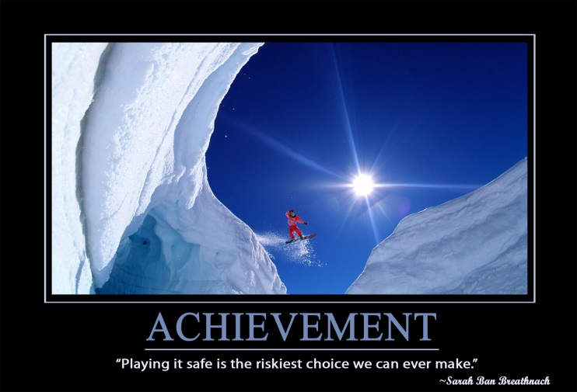
- Min. 1 adjustment (curves) layer
- Min. 1 opacity adjustment
- Min. 1 blending mode

Step 6 – Save and Hand In
Your Final Product
Save your poster as both a .PSD and a .JPEG (quality = 12). Save these two file types, along with your Planning .doc inside a folder called “loginname_nominee-poster” and hand it in. In addition to your nominee’s achievement, celebrate your own achievement! You’re done!

