“The Children of Auschwitz”
RTTQ Question
Background Information: Alexander Vorontsov, a photographer accompanying the Red Soviet Army unit that liberated the Auschwitz concentration camp on January 27, 2945, took this photo of thirteen children prior to their release.
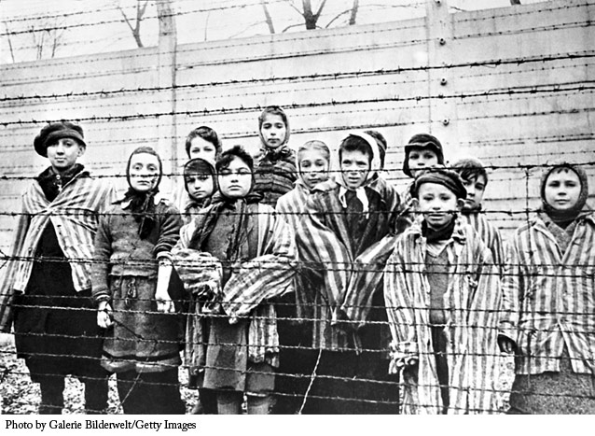

Analyze how the visual elements (colour, size, space, depth, line, expression, body language, detail, etc.) within the photo work together to convey an idea or create an overall impression.

Replace this text with your response [note: your response should be no longer than ¾ of a page, double-spaced].

