Assignment: Stop-Motion Movie
Course: 2D Animation

OBJECTIVES
Create a 10-15 second stop motion animation using your understanding of the following:
Stop-motion Storyboarding Frames Frames per second Storytelling Timeline

THE ASSIGNMENT PART
Here is the breakdown of what you need to do:

In order to achieve the objectives listed above, you will create a short, photographic animation in the form of a stop-motion movie. You will complete this project in pairs. To produce this animation, you will use a camera, tripod, software program called Premiere Pro Elements, and your imagination. Since this animation will be longer than any you’ve done before, you will be required to create both a mind map and storyboard to keep you on track. In order to achieve the assignment’s length requirement you will need to do some simple math, and manipulations within Elements.

Your animation must be between 10-15 seconds long, and follow a frame rate of 15 fps. This means that you will need to take between 150 (10 seconds x 15 fps = 150 frames) and 225 (15 seconds x 15 fps = 225 frames) photographs. You may use any kind of medium you want, as long as you have at least: 1 character, 1 background, and 1 prop.

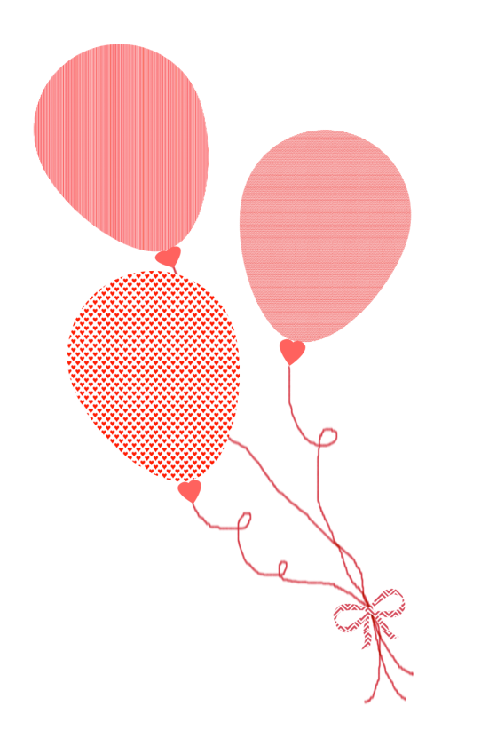
So, what should the subject of your animation be? Something relatively simple. Animation can get pretty complicated pretty quickly, and you have a time limit of ~2 weeks to complete this project. It should, however, be a little more complex than your flipbook animation, since you have a longer period of time to tell a story from beginning to end. Keep in mind that you will also have to create your own characters, props, and background. Here are some mediums (forms) you might consider using:
- Clay Whiteboard Lego
- Dolls Household Objects Live Models
- Paper Many, many more – use your imagination!

THE SPECIFICS PART
Here is a more detailed breakdown of the steps you need to take

Step 1: Mind Map
Use the example below as a guide to help you plan out your own animation. Create a mind map like the one below using www.mindmeister.com (you will need to create a free account using your school email) OR use pencil and paper, (you will need to scan this into the computer).
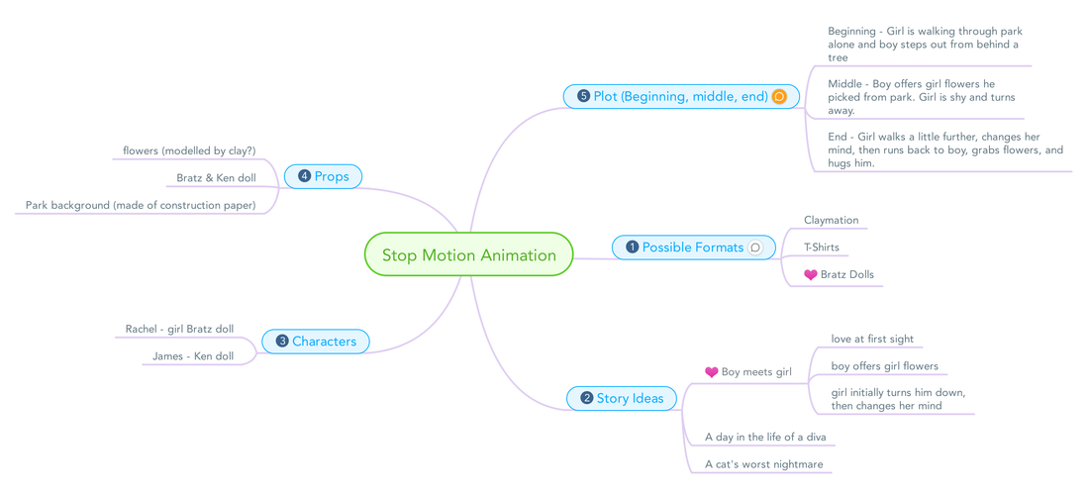

Step 2: Storyboard
Create a 6-scene storyboard for your animation. Each box on your storyboard should contain a visual representation of element of plot: beginning, introduction of conflict, rising action, climax, falling action, ending. The lines below each box should contain the following information: description of what is happening in the scene, duration of the scene (in seconds), any sounds or music you plan on adding to the scene. Create your storyboard using www.storyboardthat.com (you will need to create a free account using your school email) OR the pencil and paper template provided (you will need to scan this into the computer).

Step 3: Build
Create your characters, props and background. You must have at least 1 of each. A word of wisdom – keep these items simple… you should only be budgeting 1-2 classes for building. If you want to create complex characters and scenes, you will have to spend some time outside of class.

Step 4: Photographs
Sign out a digital camera (the same one, with the same settings) and tripod, then begin capturing the frames that will eventually make up your stop-motion animation. The most efficient way of doing this is to have one partner run the camera, and the other move and position the scenes.
- Camera Settings: 1920 x 1080 pixel image size (16:9 aspect ratio)
- Importing: use a USB cord to connect your camera to your computer. The computer that you use to import your images for the first time will be the computer you must use for the rest of this project (the D drive is that particular computer’s hard drive).
- Organization: Create a folder inside your computer’s “://D” drive called “username1_username2_stopmotion.” Inside this folder, create another folder called “stopmotion_images.” Each time you import images from your camera, create a new folder inside this folder (call it Day1, Day2, Day3, etc.) and import the images here. Once you’ve imported, delete all images from your camera’s memory.
Step 5: Premiere Elements
Open the Premiere Pro Elements Video Editor. You will be doing all your work in Editing (tab at the top of the screen) view, using the Timeline at the bottom of the screen. To prepare your project for stop-motion, go to Edit > Preferences > General, then change the “Still Image Default Duration” to “2.” This will result in your images moving at a rate of 15 fps. Save your project to the “username1_username2_stopmotion” folder you created on the “://D” drive. Call it “username1_username2_stopmotion.” Navigate to the window in the bottom left corner. Click the Media Browser tab to add your images to the timeline. Make sure that you add them in order (Day 1, then Day 2, etc.) – otherwise you will have to arrange them along the timeline by hand!

Step 6: Audio
Visit a copyright-free audio download website (like the ones provided in the bulleted list below) to browse, preview, and download audio that compliments your animation. Add it to your Premiere Elements document in the same way you added your images. It will appear in the “audio” section of the timeline. From here, you may position, cut, and delete pieces of your clip to make it fit your movie. Feel free to include sounds, voiceovers, and/or music. Music is easiest. My go-to sites:
- Sound Effects – www.soundbible.com (download the .mp3 version of the sound)
- Music – www.bensound.com (click the “download” button to download the .mp3 version of the song)
- Music – www.freemusicarchive.org (click the arrow to download the .mp3 version of the song)

Step 7: Export & Hand In
Once you are finished adding your images and audio to your Premiere Elements document, click File > Export > Media… in the top right-hand corner. Leave ALL of these overwhelming settings the same, except 1: under “Export Settings” (the very top drop-down menu) click on your video’s “output name.” In the pop-up window, change the file name to “username1_username2_stopmotion” then navigate to your computer’s “://D” drive, then the stopmotion folder you created inside. Click save. Now click on the “Export” button in the bottom right corner. Close Premiere Elements. Copy and paste your .avi file (the one you just exported) from your “://D” drive to your Student Drive. Title it “username1_username2_stopmotion.” Hand ONLY your finished animation into the Shared > Hammond > Hand In folder.

