Annotated Anthology
The war cannot stop

Rostak Polyniak

Grade 12 Comprehensive ELA

Ms. Hammond

May 10, 2017

Introduction

Between 1900 and 1999 there were many bad things happening, but people eventually stopped these bad things. In the early-mid 1940s, Hitler and his Nazi party gathered millions of Jewish people and held them as prisoners in concentration camps within Poland and Germany. In these camps the Jews were treated terribly and forced to work for free until they were sent to their deaths in the gas chambers. Even though the Holocaust was a terrible event, eventually the Russian and American armies came to the camps and stopped them.

In the new millennium, humans are even more inhumane than in the last millennium because there are bad things happening, but nobody cares enough to stop them. There are lots of people who died and there are lots of kids who died. It is hard for the kids to lose their parents because their parents are going to the war and some of the parents can’t come home because they died so it is hard for the kids at a young age.

Pro-Russian Rebels in the Ukraine

The article is about Ukraine and pro-Russia rebels signing a ceasefire deal, which is a truce deal to end almost five months of fighting. Even though the deal was signed, fighting was reported around Donetsk and Mariupol city about 70 miles to the south More 2,600 people have died since the war start. There was family that died – it was Lubov Vasylivna's grandchildren. Nikita was 10 year old Nikita, who was disabled, and his six-year-old sister, Karolina. This shows that humans are inhumane because the rebels are shooting the Russian and Ukrainian soldiers, as well as civilians – even young kids.
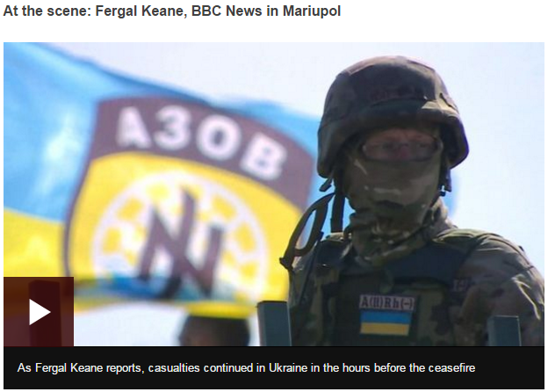

Read More at: http://www.bbc.com/news/world-europe-29082574

http://www.holodomorct.org/

